**Employee table (Empl)**

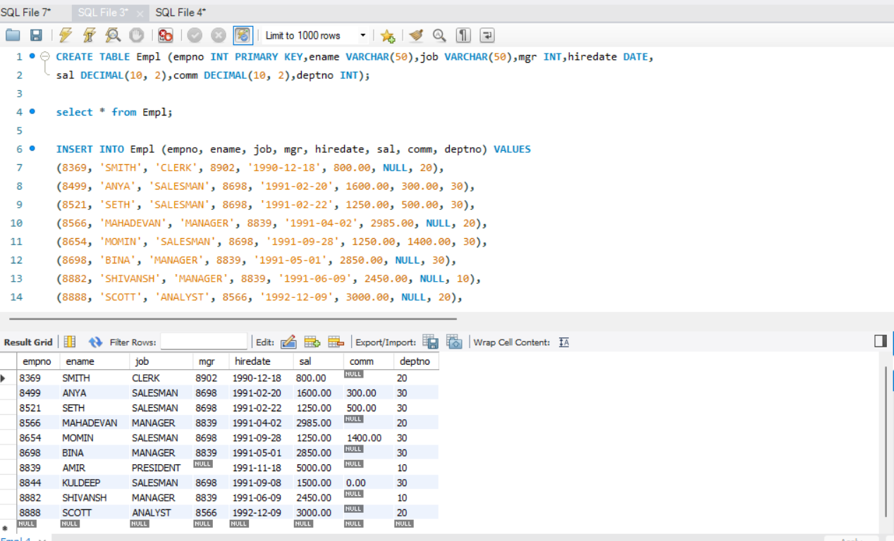

**Display EName and Sal of employees whose salary is greater than or equal to 2200**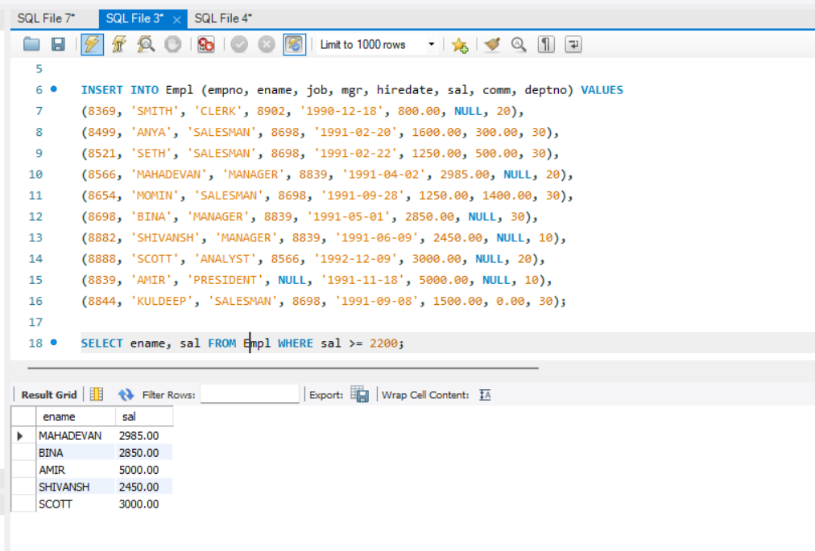

**Display details of employees who are not getting commission**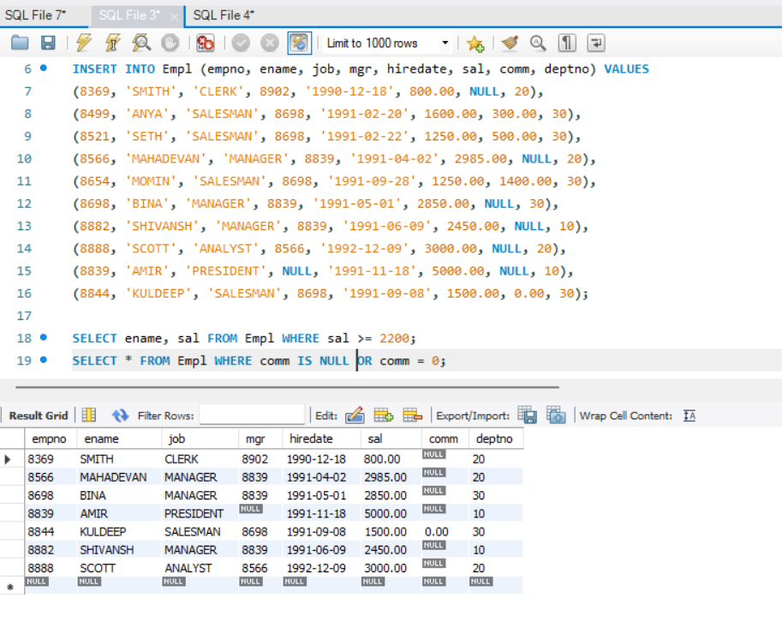

**Display employee name and salary of those employees who don’t have their salary in the range of 2500 to 4000**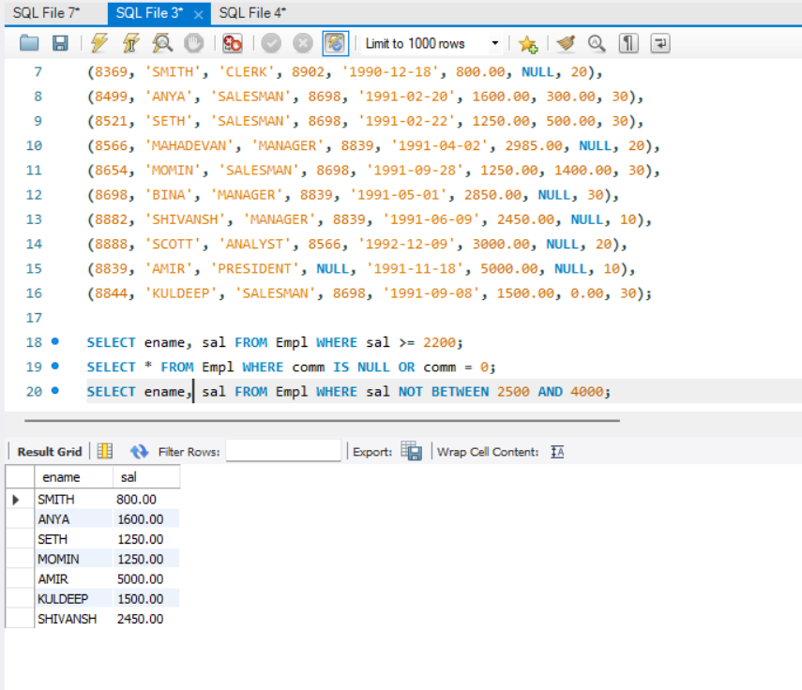

**Display the name, job title and salary of employees who don’t have a manager**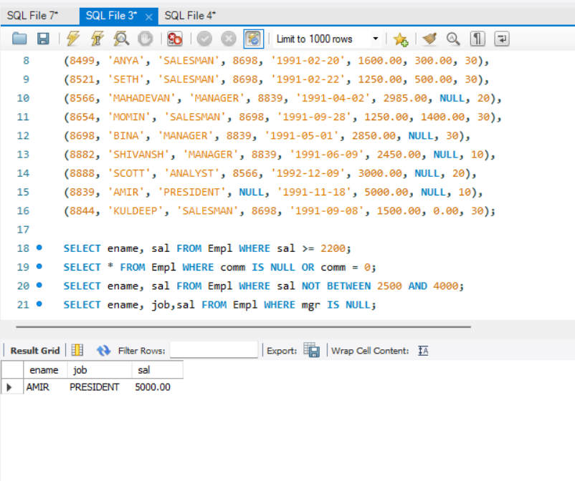

**Display the name of an employee whose name contains “A” as third alphabet**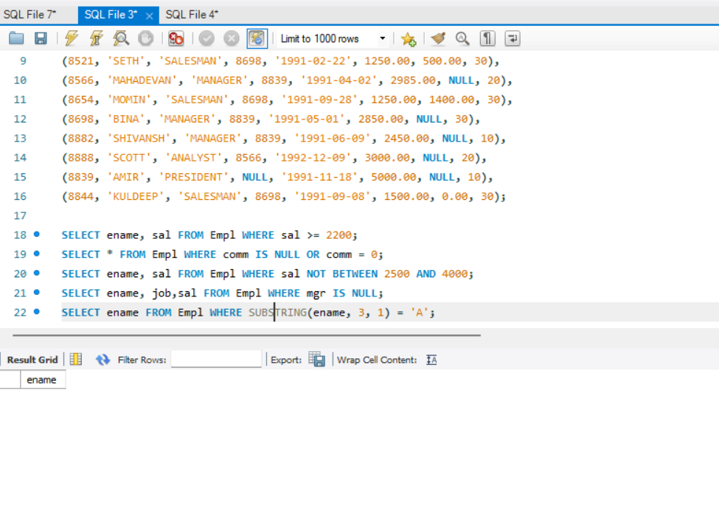

**Display the name of an employee whose name contains “T” as the last alphabet**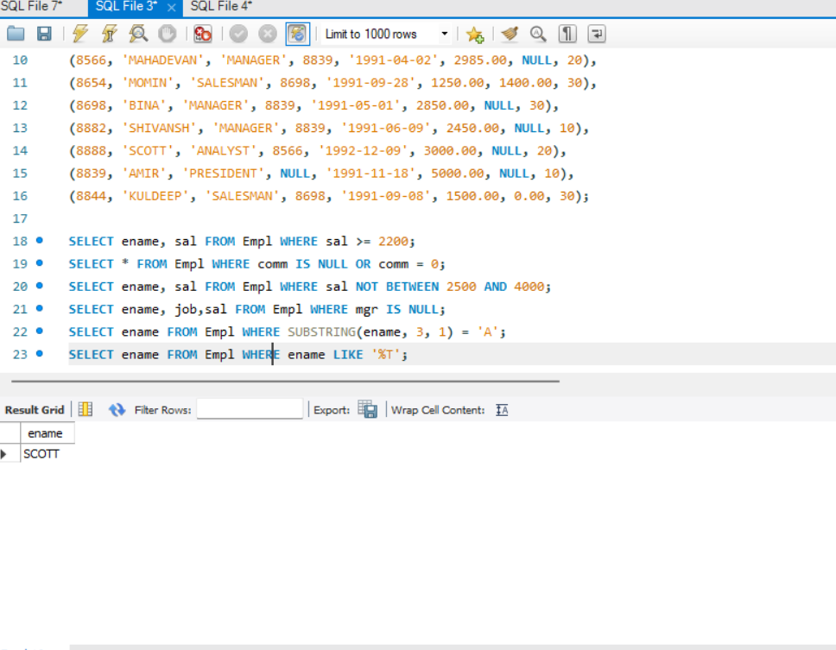

**Q2**

